Intelligent Submersible pump for Irrigation

Purposes.

Miss Sanjana Kulkarni, Under Guidance of Dr. Laxmi B Rananavare

*Student, Computer Science Engineering, Reva, Bengaluru, Karnataka State, India,*

*Assistant Professor, Computer Science Engineering, Reva, Bengaluru, Karnataka State, India,*

***Abstract*** — ***India is the country of village and agriculture. Agriculture plays an important role for the development of country. Agriculture depends on the climate change, in monsoon season the availability of water sources for the agriculture purpose is insufficient. In order to overcome this, the irrigation is used in agriculture field. Nowadays most of the farmers in India follow irrigation process by using bore well electric pumps or lift irrigation. Electric pumps of varying capacity from 3HP to 15 HP are used for pumping the water. But the farmers in many villages do not get good quality of power for irrigation. Farmers also face many problems like unscheduled load shedding, under voltage, over voltage, dry run of motor, and so on. Due to these problems finally electric pumps get burn out. The cost of replacing or repairing of electric motor will be very high. Therefore research is going on the protection of motors against these faults.***

***In this project, an intelligent protection and control system has been designed for the protection of electric motors using IoT and sensors. The prototype model has been developed which protects the motor against under-voltage fault, over-voltage fault, temperature fault, and dry run. The voltage sensors, water level sensors and temperature sensors connected detects the fault and sends the information to the microcontroller which intern sends the signal to the relay to stop the motor thus protecting the complete pumping system. The user can access the information about the various faults of the system using IoT and also he can control the ON/OFF operation of the electric motor using the IoT.***

**Keywords: Microcontroller, IOT, voltage sensor, Magnetic Level sensor, temperature Sensor, Submersible pump.**

# INTRODUCTION

India is mainly an agricultural country. Agriculture is the most important occupation for most of the Indian families. In India about 70% of population depends upon farming and one third of the nation’s capita income is from farming, agriculture contributes about sixteen percent of total GDP (Gross Domestic Product) and ten percent of total exports. Agriculture is the backbone of Indian economy. Though, with the growth of other sectors, the overall share of agriculture on GDP of the country has decreased. Still, Agriculture continues to play a dominant part in the economic scenario of India. Issues concerning agriculture have been always hindering the development of nation. In our country, agriculture depends on the monsoons which has insufficient source of water. So the irrigation is used in agriculture field. Nowadays Most of the farmers in India follow irrigation by bore well electric pumps or lift irrigation by tanks, river streams using electric pumps of varying capacity pumps from 3HP to15 HP. Farmers in villages do not get good quality of power for irrigation.

Farmers face many problems like unscheduled load shedding, under voltage, sometimes phase blank out problems etc. Due to these problems finally electric pumps get burnt. To replace or repair burnt electric motor, there will be heavy investment again which cannot be afforded. To overcome motor burn out due electric fluctuation it is proposed to develop an intelligent protection and control using “Internet of Things”.

# LITERATURE REVIEW

**Literature Survey on Submersible Pump:**

An electric submersible pump (ESP) is an artificial lift device used in oil and gas production units for achieving high rate of recovery. Standard ESPs are equipped with multi-stage high peed centrifugal pumps or low speed progressive cavity pumps. ESPs are traditionally driven by hermetically sealed submersible induction motors (IMs) [1].

IMs have lower efficiency, thermal stability and power quality than permanent magnet motors due to constant slip power losses in the rotor cage [1]

Electric submersible pumps (ESPs) are wide deployed for oil and gas production from deep down whole reservoirs. ESPs are located inside a well from hundreds to several thousands of feet below the surface. A variable speed drive (VSD) is situated on the surface platform, and power is supplied to the ESP from the VSD through long down whole cables that run down the well. Due to the long cable length, position sensor based speed controllers for traditional IPM drives are impractical for ESPs [1]

The energy efficiency of plants (ESPs) is primarily related to the reduction of energy losses in the power channel of energy conversion. Currently, the ESP power channel is completed with CS of domestic (Novo metPerm‟, Tirol, Alas, Etalon, IRZ group of companies) and foreign production equipped with inverters for the SEM energy-efficient control.

In recent years, permanent magnet submersible motor (PMSM) driven ESPs have been introduced in the market which provides better efficiency, smaller dimensions, wide operating range, lower heat generation and superior performance than same size IM driven ESPs . However, PMSM-ESPs have not gained the popularity due to control problems associated with the nonlinearity in PM motors[2]

**Literature Survey on IoT:**

Internet of Things (IoT) is a recent model which involves communication and sees future in technology, where each and every technology related things such as microcontrollers, transceivers for digital communication, and suitable protocol stacks that will enable communication with each other’s and with users thus forming IoT upon integration.[3]

Agriculture with IoT automation gives most effective and efficient results, cost-effective and reduce human efforts solution.

Following are advantages of involving IoT in agriculture:

IoT enabled devices in agricultural land enables Connectivity to a diverse range of devices – From Android and iOS-based mobile, tablet and TV devices to standalone devices IoT can be connected to almost anything that can be connected and interfaced from the internet reduced Human efforts. Quick access as parameters can be monitored remotely via devices.

**Literature Survey on Sensors:**

Sensors are used for monitoring the level of liquids in storage reservoirs, containers and tanks. Multiple alternative liquid level measurement techniques have been applied, such as magnetic, radar, ultrasonic etc., since varying the range, installation conditions and liquid type impose different specifications for the sensor. Water-level sensors are indispensable for monitoring the level of water in storage tanks, which are used in drinking water distribution networks.[1]

pH Sensor – The sensor keep track of readings from the soil and the health of the soil. This gives data on efficiency or deficiency of pesticide or fertilizers.

DHT11 – Temperature and Humidity Sensor. This sensor keeps a track of the temperature and humidity in the crop field environment Soil moisture sensor – This is used track the moisture level in the soil.[4]

Agriculture with IoT automation gives most effective and efficient results, cost-effective and reduce human efforts solution.

Following are advantages of involving IoT in agriculture:

* IoT enabled devices in agricultural land enables Connectivity to a diverse range of devices – From Android and iOS-based mobile, tablet and TV devices to standalone devices IoT can be connected to almost anything that can be connected and interfaced from the internet.
* Reduced Human efforts
* Quick access as parameters can be monitored remotely via devices.
* Time Efficient
* Effective and efficient communication using phones etc
* We can easily analyses the issues and parameters in case of failure [4]

as in, this work is based on the idea to exploit the capacitive voltage sensors within the medium-voltage substation [8].

# OBJECTIVES AND METHODOLOGY

**Objectives:**

The objectives of project are given below:

1. To perform the literature survey on Submersible pump and study about IoT.
2. To design the circuit diagram of control unit by using sensors and perform simulation of same.
3. To develop the programme of control operation in embedded C language.
4. To design circuitry for the Water level detection inside the Borewell using the sensors.
5. To design circuitry for the detection and control of under voltage, over voltage, phase out faults and temperature of the motor using sensors.
6. To obtain the automatic protection & control of motor using sensors & IoT.

**Methodology:**

Methodology for Objective 1:

1. To study about the existing pump set used for irrigation purpose.
2. To study about the different types of pump available in market.
3. To study about the IoT technology & its implementation.

Methodology for Objective 2:

1. To study about the different types of sensors.
2. To draw the circuit diagram of control unit with sensors.
3. To simulate the control circuit in simulink software.

Methodology for Objective 3:

1. To write algorithm and flowchart of the motor control operation.
2. To design the flow chart as per the algorithm written.
3. To develop the program in the embedded C and burning it in the Atmega chip.

Methodology for Objective 4:

1. To install the water level sensors in Borewell.
2. To study Water level conditions in the Borewell by the sensors installed.
3. To test all the circuitry and detect the water level & its flow.

Methodology for Objective 5:

1. To study about the standard working temperature of the pump.
2. To install the sensors & microcontrollers for detecting and controlling of motor in undesired voltage conditions and undesired temperatures.
3. To implement and test all the parameters to detect the undesired voltage, temperature & protect the motor from fault.

Methodology for Objective 6:

1. To create prototype of bore well.
2. To install IoT system to monitor online.
3. To install the intelligent pump system to test all the parameters as in the objectives.
4. To implement and control the operations of motor automatically in fault condition.
5. Based on results of analysis and observations the detailed report of design, operations performed and the output obtained to be reported.

# EXPERIMENTAL WORK

Figure 1 represents the block diagram of the project. It contains all the individual components required for monitoring and controlling voltage, water level, and temperature in irrigation system and also to the system through internet. The microcontroller used in the circuit monitors the different parameters inside the circuit. The circuit is designed to control all the specific parameters like voltage, temperature & water level.

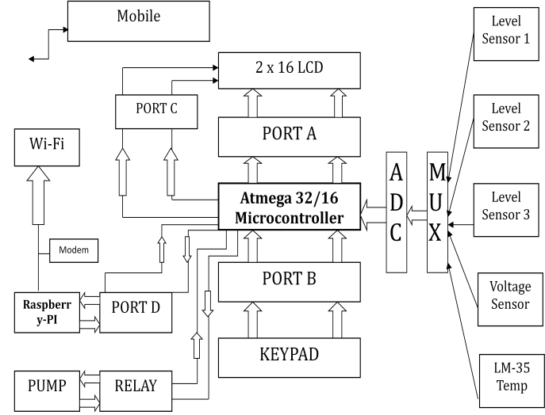

Figure 1: Block Diagram

V

R1

1

k

2

1

0

C1

0.1

uF

1

2

V1

FREQ = 50

VAMPL = 12v

VOFF = 0

D1

D1N4007

V

Figure 2: Simulation of rectifier circuit

The Figure 2 represents the simulation diagram of a rectifier circuit used power supply for the microcontroller. The design is developed in Orcad and output waveform is represented in the figure 3.

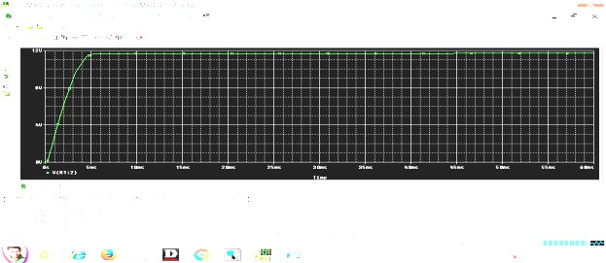

Figure 3: Output waveform of the circuit

**Hardware Result**

*Water Level Detection*

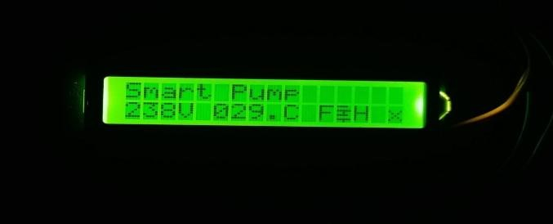

Figure 4: Water Level Indication in LCD

The Figure 4 represents the Water level in the Borewell sensed by the sensors install .

*Voltage Level Detection*

The Figure 5 represents low voltage detection from the supply by the voltage sensor installed.

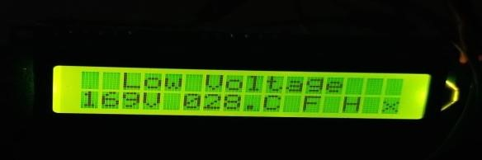

Figure 5: Low Voltage Detection

The figure 6 represents high voltage detection from the supply by the voltage sensor installed.

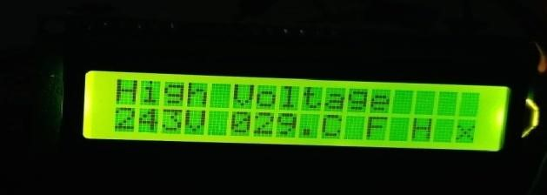

Figure 6: High Voltage Detection

*Mobile Monitoring and Operation*

The figure 7 shows the operational parameters obtained through IoT.

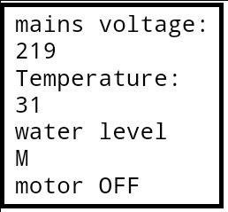

Figure 7: Display of parameters using IoT

# CONCLUSION

In this project, an intelligent protection and control system has been designed and developed for the protection of electric motors used for irrigation purpose using IoT and sensors. The prototype model has been developed which protects the motor against under-voltage fault, over-voltage fault, temperature fault, and dry run. The project is designed for the detection of water levels, voltage levels, temperature levels of submersible pump and to perform safer operation and protection of the

system against various faults. The usage of Raspberry Pi system provides information to the user about operating condition of pump and also to control the submersible pump through wireless mode. The project is aimed to work efficiently by using magnetic fluid level sensors, voltage level sensors and LM35 temperature sensors for reducing the interruptions for the working of submersible pumps.

In this project, the motor used for irrigation purpose is automatically protected from various faults such as over voltage, Under Voltage, High temperature and Dry run of motor. The operating conditions of the complete system will be received by the user with the help of internet.

**VI. REFERENCES**

1. R. Brinner, “Induction versus permanent-magnet motors for electric submersible

pump field and laboratory comparisons.,”

IEEE Transactions on Industry,

Applications, vol. 50, pp. 174-181, 2014.

[2] F. Rabbi, “Modeling and Performance Evaluation of a Hysteresis IPM Motor

Drive for Electric Submersible Pumps,” in Proc. of the IEEE ECCE 2015,

Montreal, 2015.

[3] Andrea Zanella,Lorenzo Vangelista ,"Internet of Things for Smart Cities,"IEEE INTERNET OF THINGS JOURNAL, VOL. 1, NO. 1, FEBRUARY 2014.

[4] Mrs. Vaishali Puranik,Mr. Ankit Ranjan,Mrs. Sharmila,Ms. Anamika Kumari ,"Automation in Agriculture and IoT,"978-1-7281-1253-4/19/$31.00 © 2019 IEEE.

JOURNAL, VOL. 1, NO. 1, FEBRUARY 2014.